**Adrien NKURIKIYMUKIZA**

**Adrien.nkurikiyumukiza@azubiafrica.org**

**Q1. How many users does Wave have?**

* SELECT COUNT(u_id) AS TotalUsers FROM wave.users;

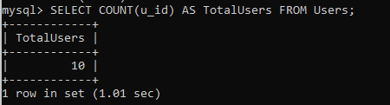

**Q2.** How many transfers have been sent in the currency CFA?

* SELECT COUNT(send_amount_currency) AS TotalTransfersInCfa

FROM wave.transfers

WHERE send_amount_currency = 'CFA';

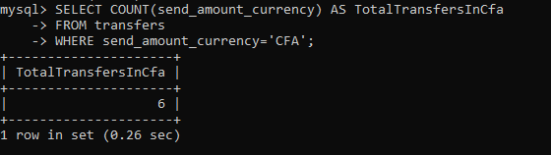

**Q3.** How many different users have sent a transfer in CFA?

* SELECT COUNT(DISTINCT user_id) AS TotalUsers, send_amount_currency AS CurrencySent

FROM wave.transfers

WHERE send_amount_currency = 'CFA';

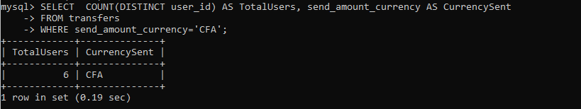

**Q4.** How many agent_transactions did we have in the months of 2022 (broken down by month)?

* SELECT MONTH(when_created),

COUNT(atx_id) AS TotalTransactions

FROM wave.agent_transactions

WHERE when_created LIKE '%2022%'

GROUP BY MONTH(when_created)

ORDER BY MONTH(when_created);

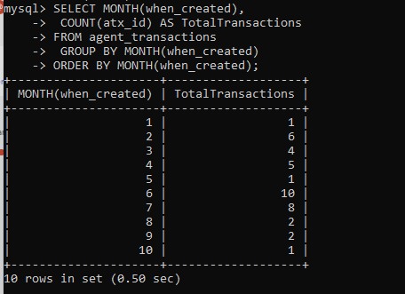

**Q5.** Over the course of the first half of 2022, how many Wave agents were “net depositors” vs. “net withdrawers”?

* SELECT agent_id, SUM(amount)

FROM wave.agent_transactions

WHERE MONTH(when_created)<7 AND when_created LIKE '%2022%'

GROUP BY agent_id

ORDER BY SUM(amount);

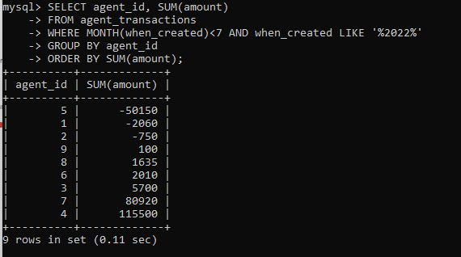

**Q6.** Build an “atx volume city summary” table: find the volume of agent transactions created in the first half of 2022, grouped by city.

* SELECT city, SUM(amount) AS Volume

FROM wave.agent_transactions

JOIN agents

ON agent_transactions.agent_id = agents.agent_id

WHERE MONTH(agent_transactions.when_created)<7 AND agent_transactions.when_created LIKE '%2022%'

GROUP BY city;

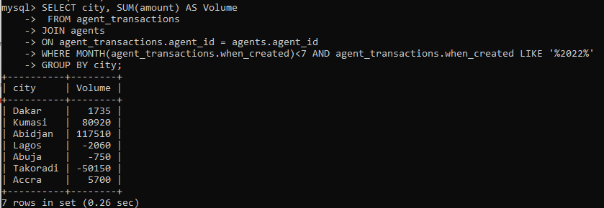

**Q7.** Now separate the atx volume by country as well (so your columns should be country, city, volume).

* SELECT country, city, SUM(amount) AS Volume

FROM wave.agent_transactions

JOIN agents

ON agent_transactions.agent_id = agents.agent_id

WHERE MONTH(agent_transactions.when_created)<7 AND agent_transactions.when_created LIKE '%2022%'

GROUP BY city;

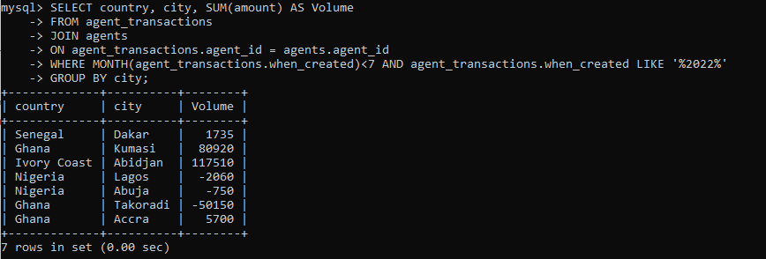

**Q8.** Build a “send volume by country and kind” table: find the total volume of transfers (by send_amount_scalar) sent in the first half of 2022, grouped by country and transfer kind.

* SELECT ledger_location AS country, kind AS transfer_kind, SUM(send_amount_scalar) AS volume

FROM wave.transfers

JOIN wallets

ON wallets.wallet_id = transfers.dest_wallet_id

WHERE MONTH(transfers.when_created)<7 AND transfers.when_created LIKE '%2022%'

GROUP BY ledger_location,kind;

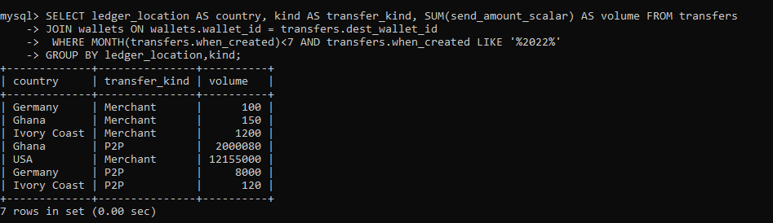

**Q9.** Then add columns for transaction count and number of unique senders (still broken down by country and transfer kind).

* SELECT ledger_location AS country, kind AS transfer_kind, SUM(send_amount_scalar) AS volume,

COUNT(transfer_id), COUNT(DISTINCT user_id)

FROM wave.transfers

JOIN wallets

ON wallets.wallet_id = transfers.dest_wallet_id

WHERE MONTH(transfers.when_created)<7 AND transfers.when_created LIKE '%2022%'

GROUP BY ledger_location,kind;

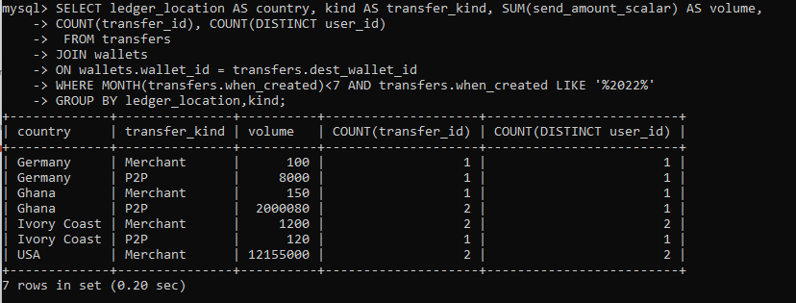

**Q10.** Finally, which wallets sent more than 1,000,000 CFA in transfers in the first quarter (as identified by the source_wallet_id column on the transfers table), and how much did they send?

* SELECT source_wallet_id, send_amount_scalar

FROM wave.transfers

WHERE send_amount_currency = 'CFA'

AND send_amount_scalar > 1000000

AND MONTH(when_created) < 4;

